***RYANA CALENDERS***

***PROJECT***

***Documentation***

***2104F***

***Acknowledgment***

I would like to acknowledge all those who have given me moral

Support and helped in making the project a success. I wish to express my gratitude to e-project team at head office who guided and helped me.

Thanks to our teacher sir **waqar hussain** who guided us during this project. Also, I would like to express my gratitude to all the staff members of my Centre for not only providing me opportunity to work with them on this project, but also for their support and encouragement throughout the process.

I am over helmed in all humbleness and gratefulness to acknowledge my depth to all Group members who made this project possible.

**Our Group members are:**

|  |  |
| --- | --- |
| **Student ID** | **Student Name** |
| Student1319271 | Ali Ahsan Samnani |
| Student1319265 | Basit Ali |
| Student1311913 | Uzair Ali |
| Student1316588 | Uzair Shakeel |
| Student1316585 | MUHAMMAD ZARAR KHAN |

***E-Project Synopsis/Analysis***

**1) Title:** RYANA CALENDARS

**2) Problem Statement:**

Ryana Calendars is selling various Calendars and Diary Products. The company advertises by distributing the pamphlets, advertising on television and so on. Due to rapid development in internet field, the company decides to launch a website where people will get all the information about the various products available with them easily.

3) **Aims and Objectives:**

Our aim is to make a responsive E-Commerce website which sells Journals, Diaries and Calendars online. It ultimately helps the customer to purchase items from the comfort of their homes.

**4) Review of Literature:**

Our website comprises of a header, Slider, About-us page, Products, Price list, contact-us page and a footer.

* Header is basically a navigation bar which shows all of these pages.
* Slider is a kind of welcome page having an attractive background image of Stationary items.
* Then, we have About us section which has a short description of our website and what we have achieved up till now.
* Moving Forward, we have products page which shows all kinds of products we have (Journals, Calendars and Diaries).
* We also have a price list; it is a word file which can be downloaded by the customers who want to see the details of the products with their prices.
* At last we have a Footer which is an important part of every website. By including navigation links in the footer, it becomes easy for site visitors to keep exploring without forcing them to scroll back up. They provide access to important information that's necessary but shouldn't get top billing (i.e. your copyright info, privacy statements, Social media handles and legal disclaimers).

**5) Software Requirements:**

* Notepad / HTML Editor or Visual Studio Code
* Dreamweaver
* Web browser

**6) Hardware Requirements:**

* A minimum computer system that will help you access all the tools in the courses is a core-i5 or core-i7 will work properly for web development.
* Minimum 8-GB of RAM will be enough for web development.

***FLOW CHART***

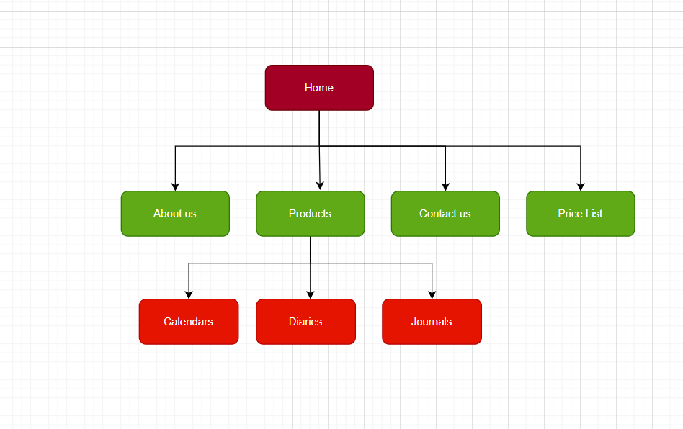

***Screenshots***

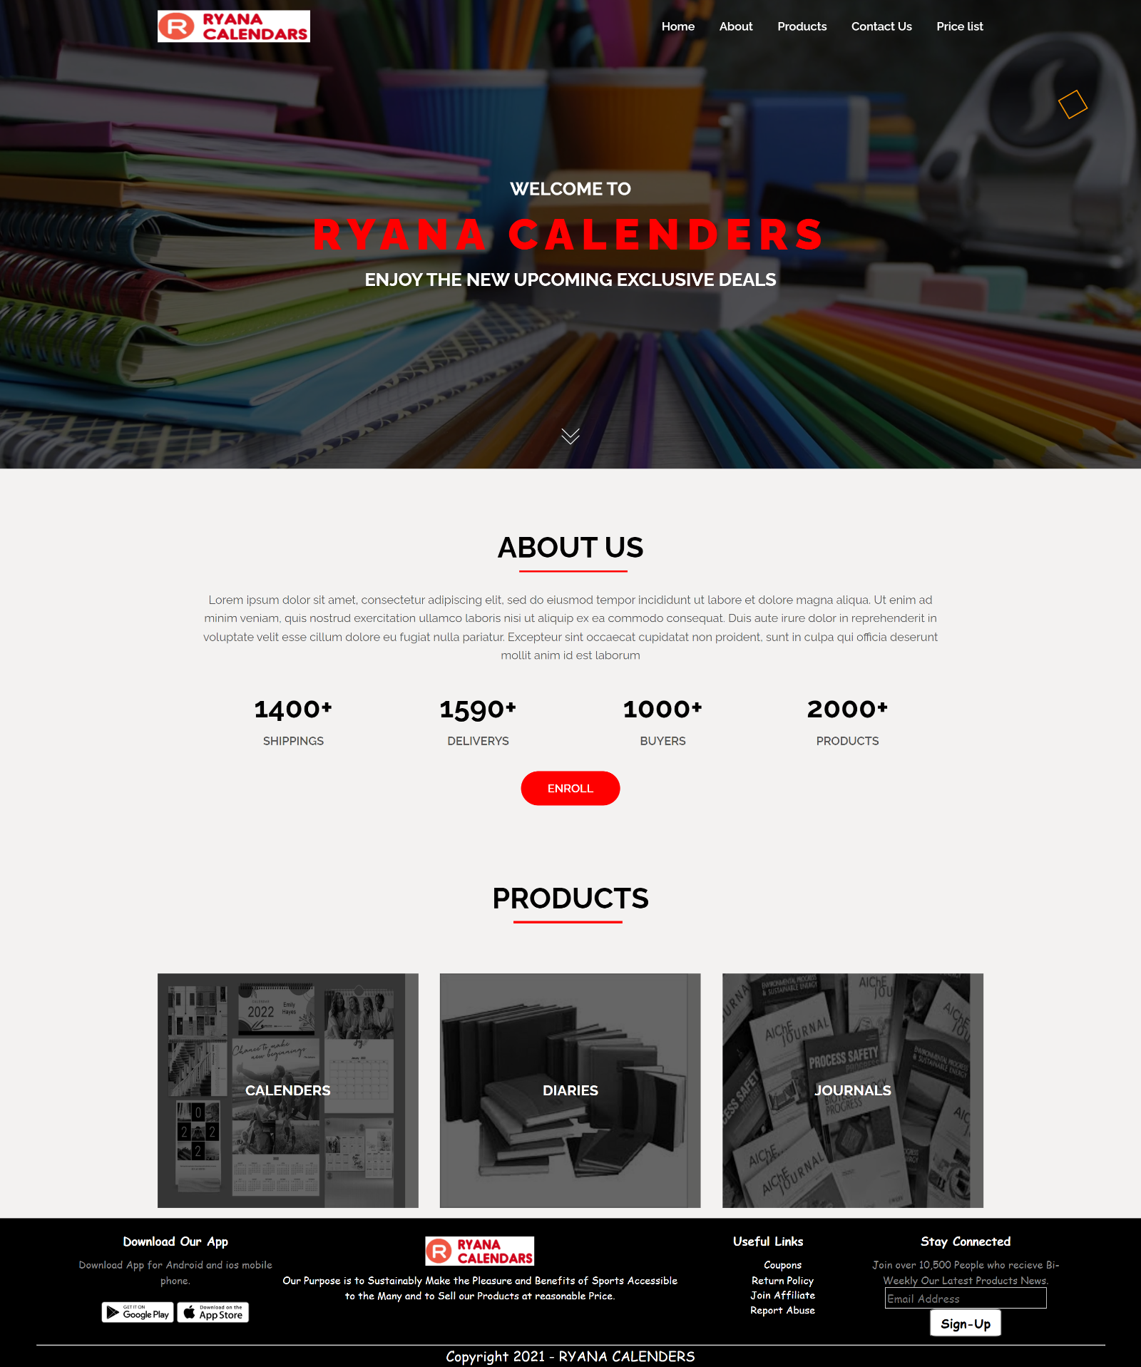***HOME PAGE:***

***PRODUCTS PAGE (CATEGORY):***

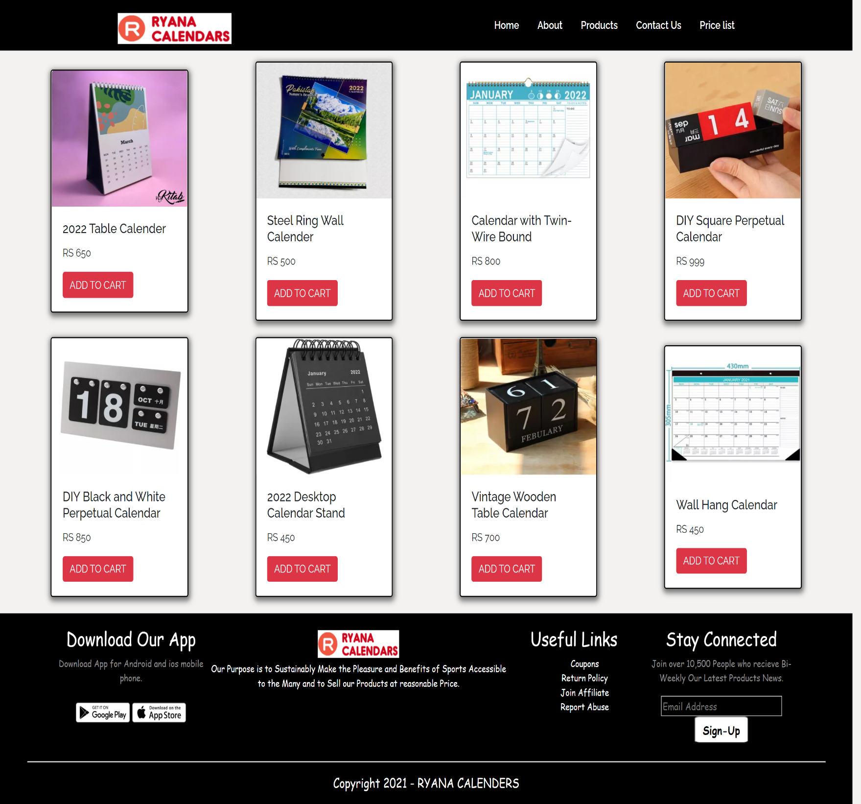***CALENDAR PAGE:***

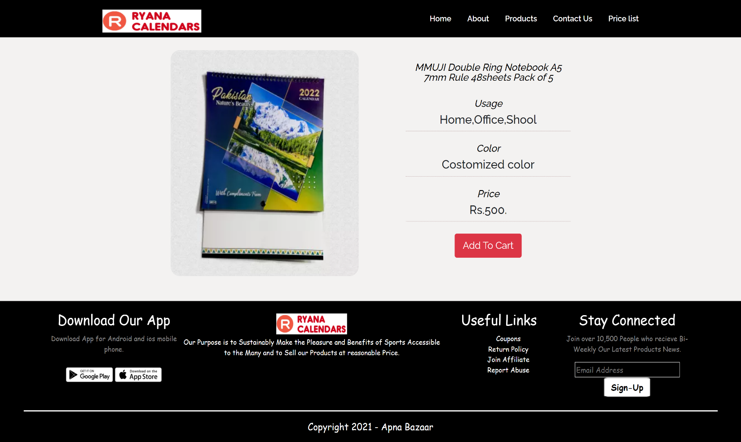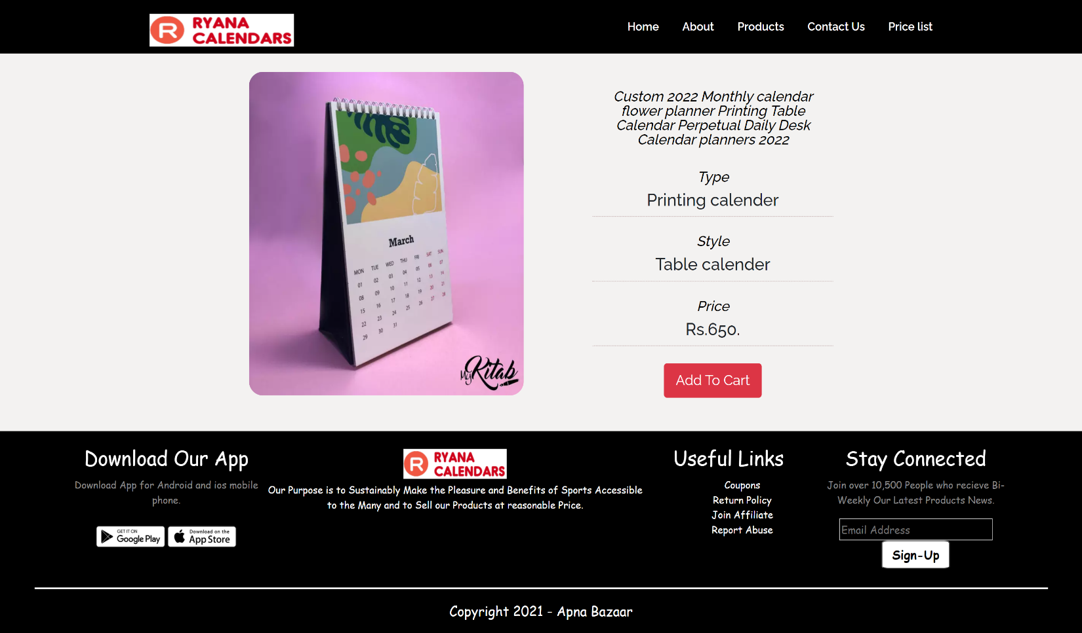***CALENDAR ITEMS INDIVIDUAL PAGES:***

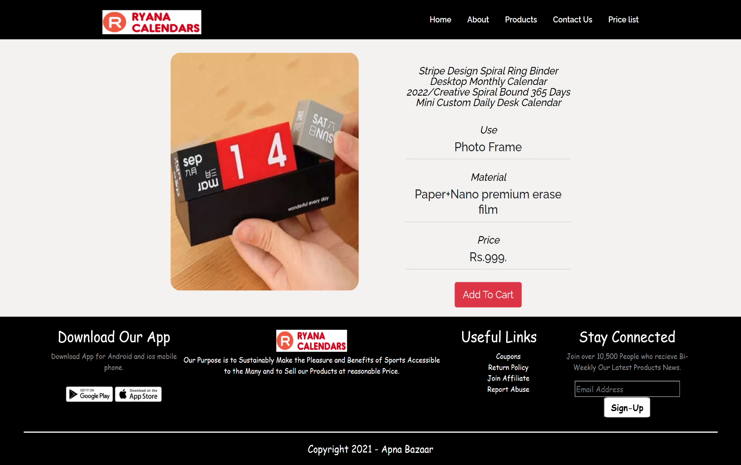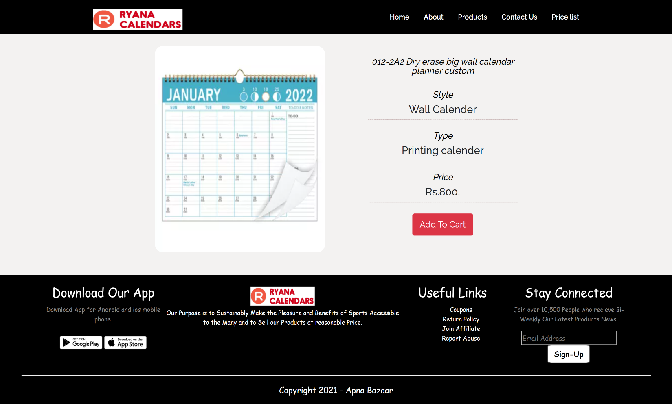

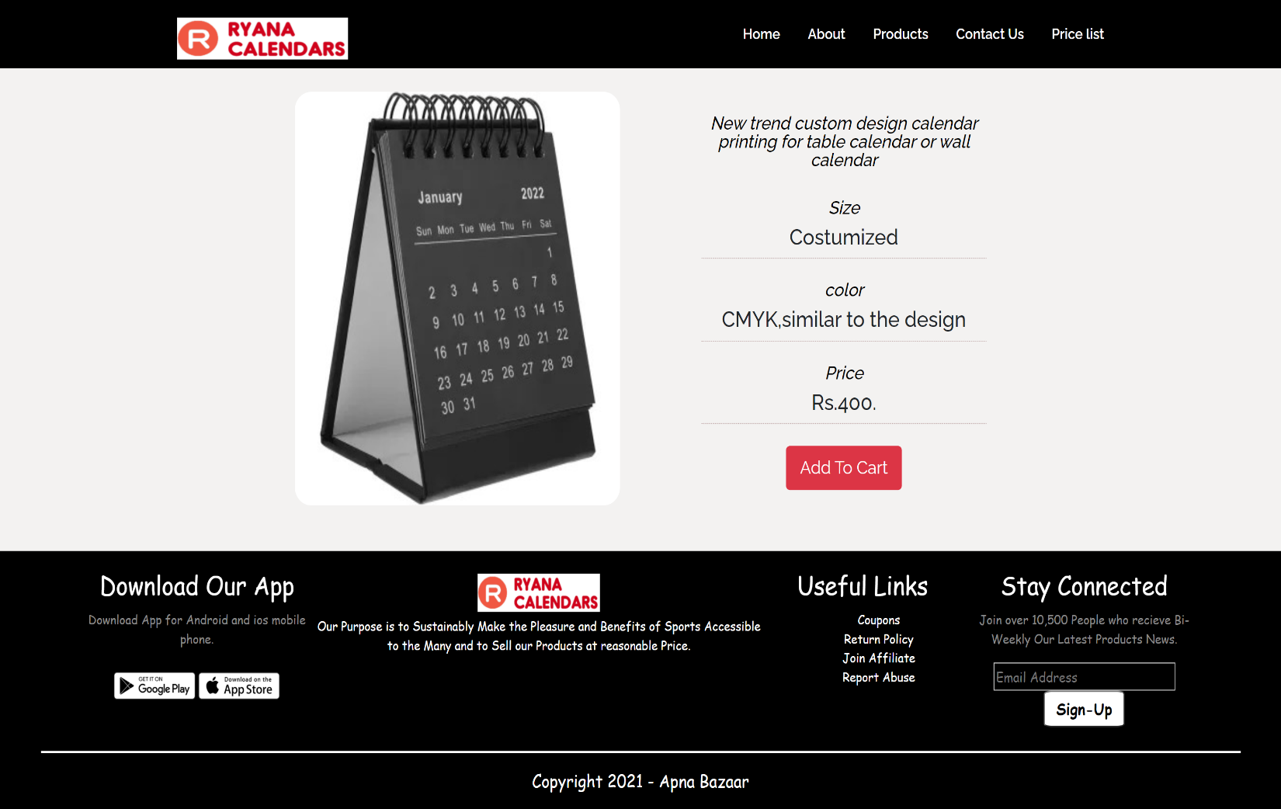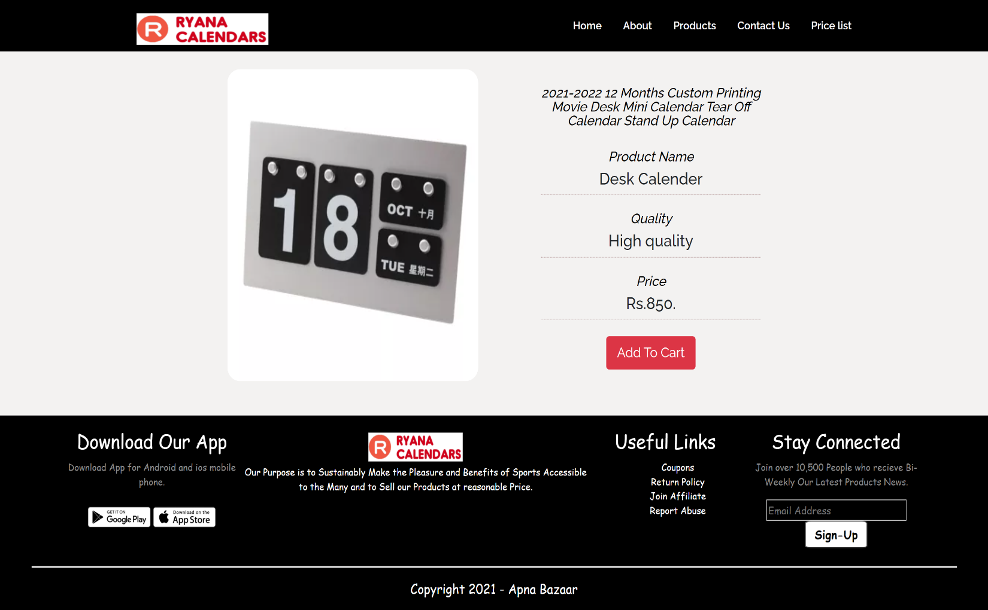

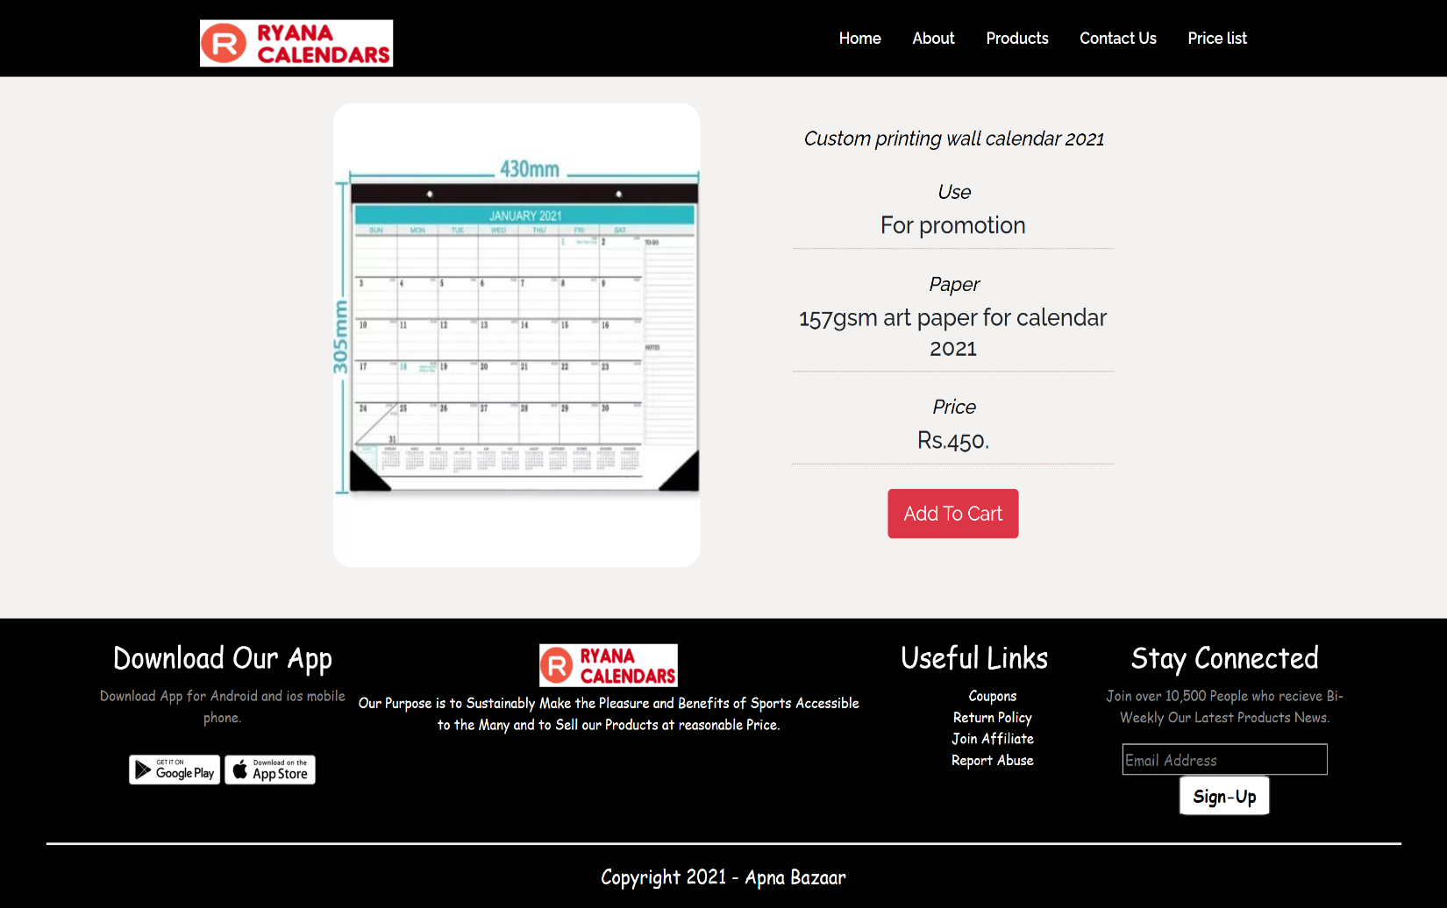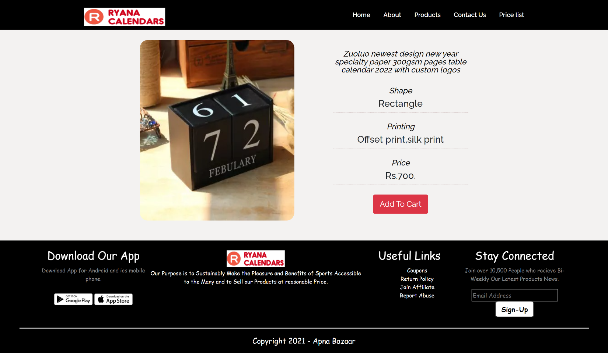

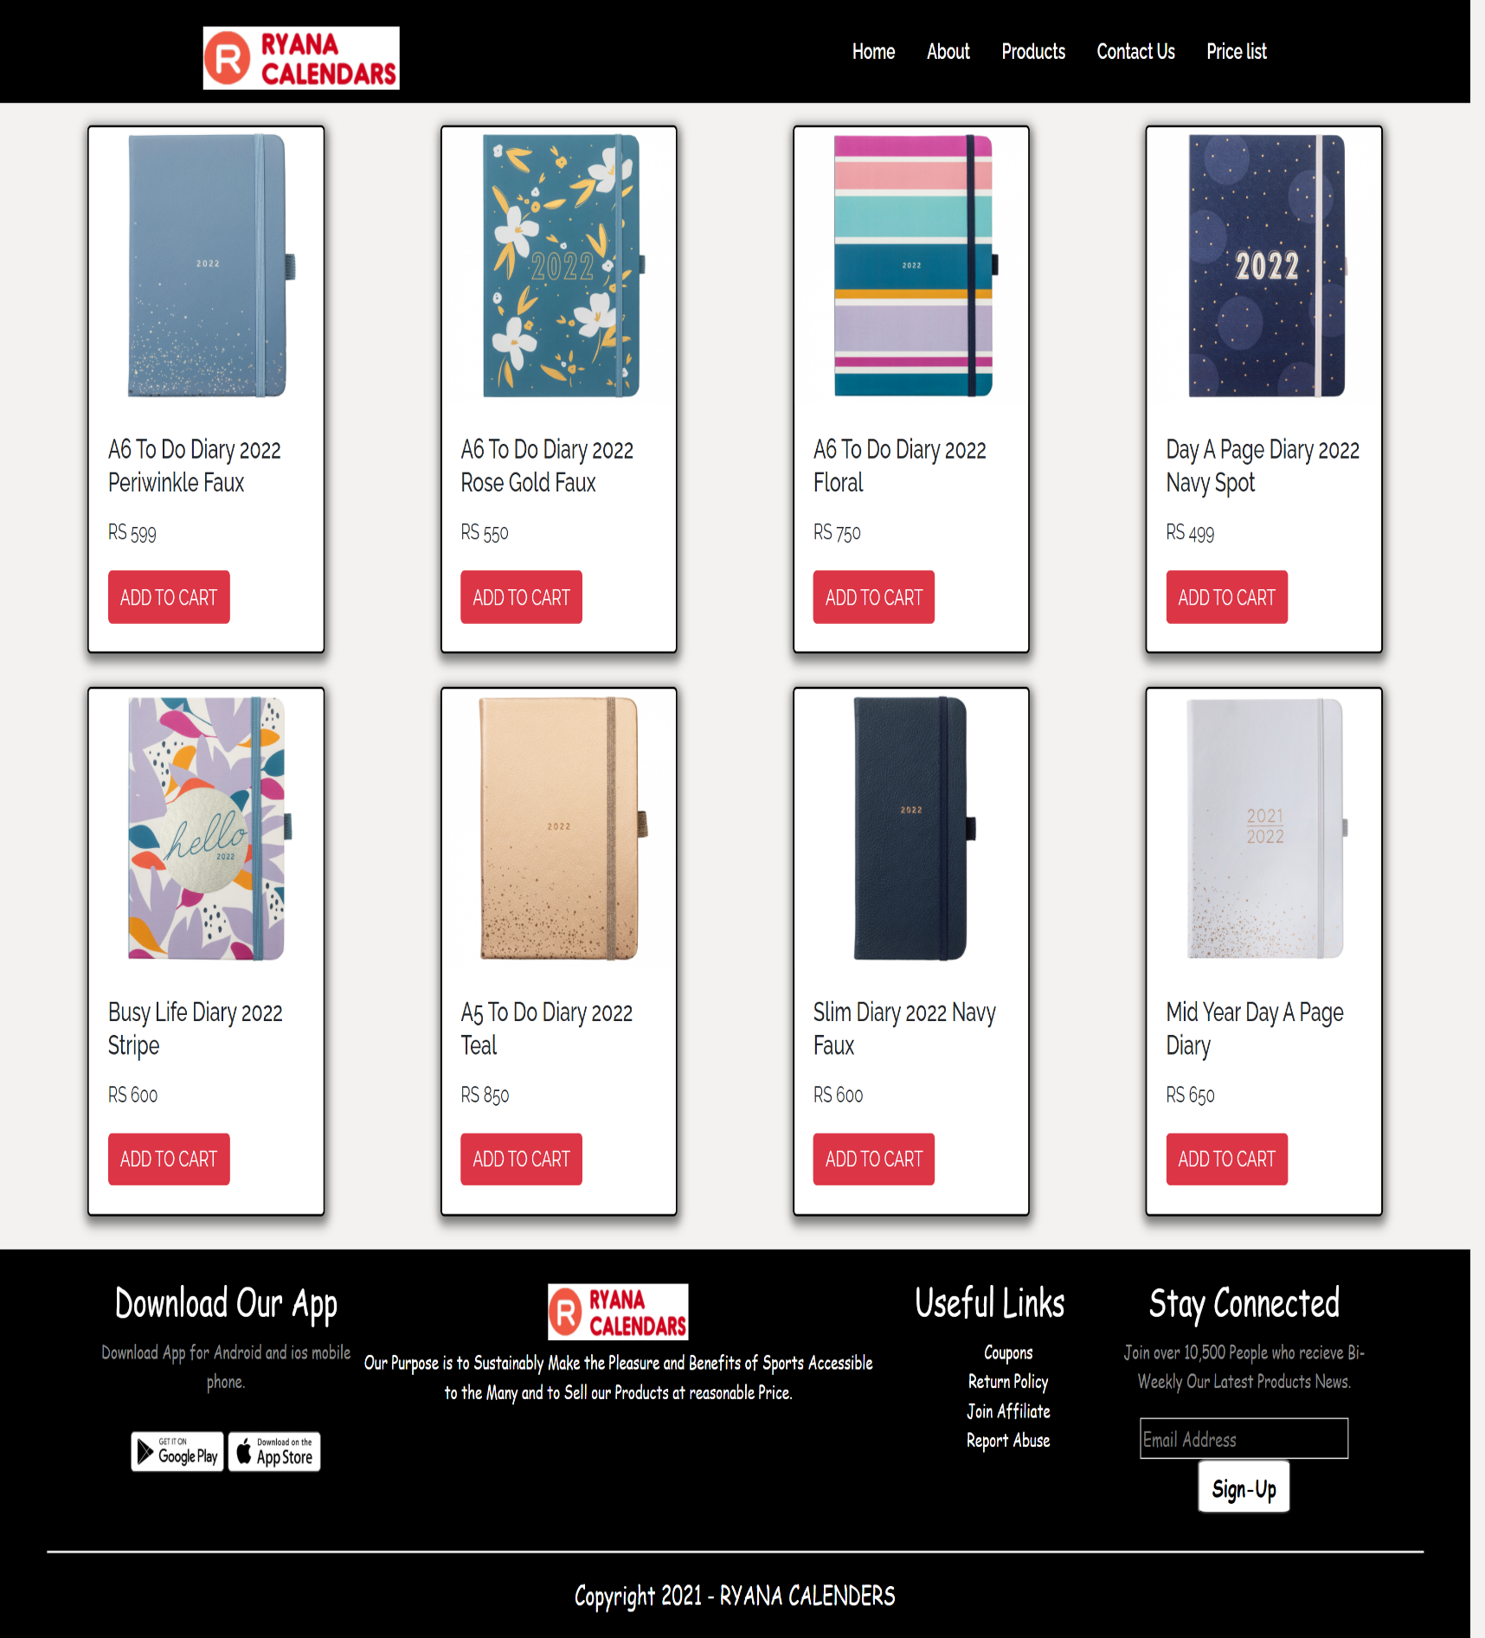***DIARY PAGE:***

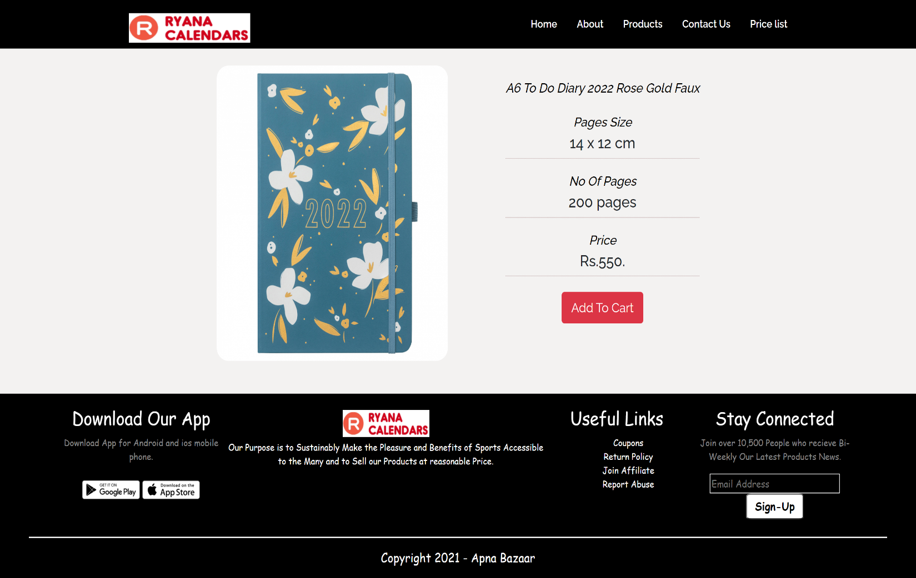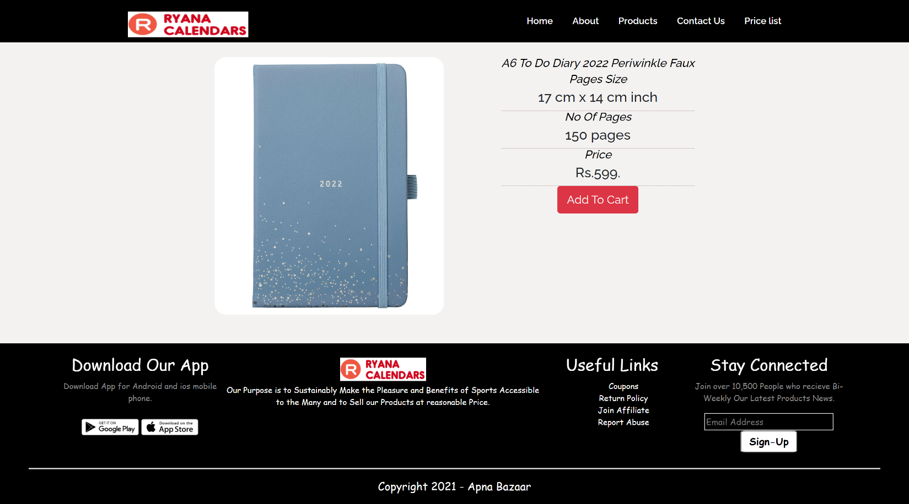***DIARY ITEMS INDIVIDUAL PAGES:***

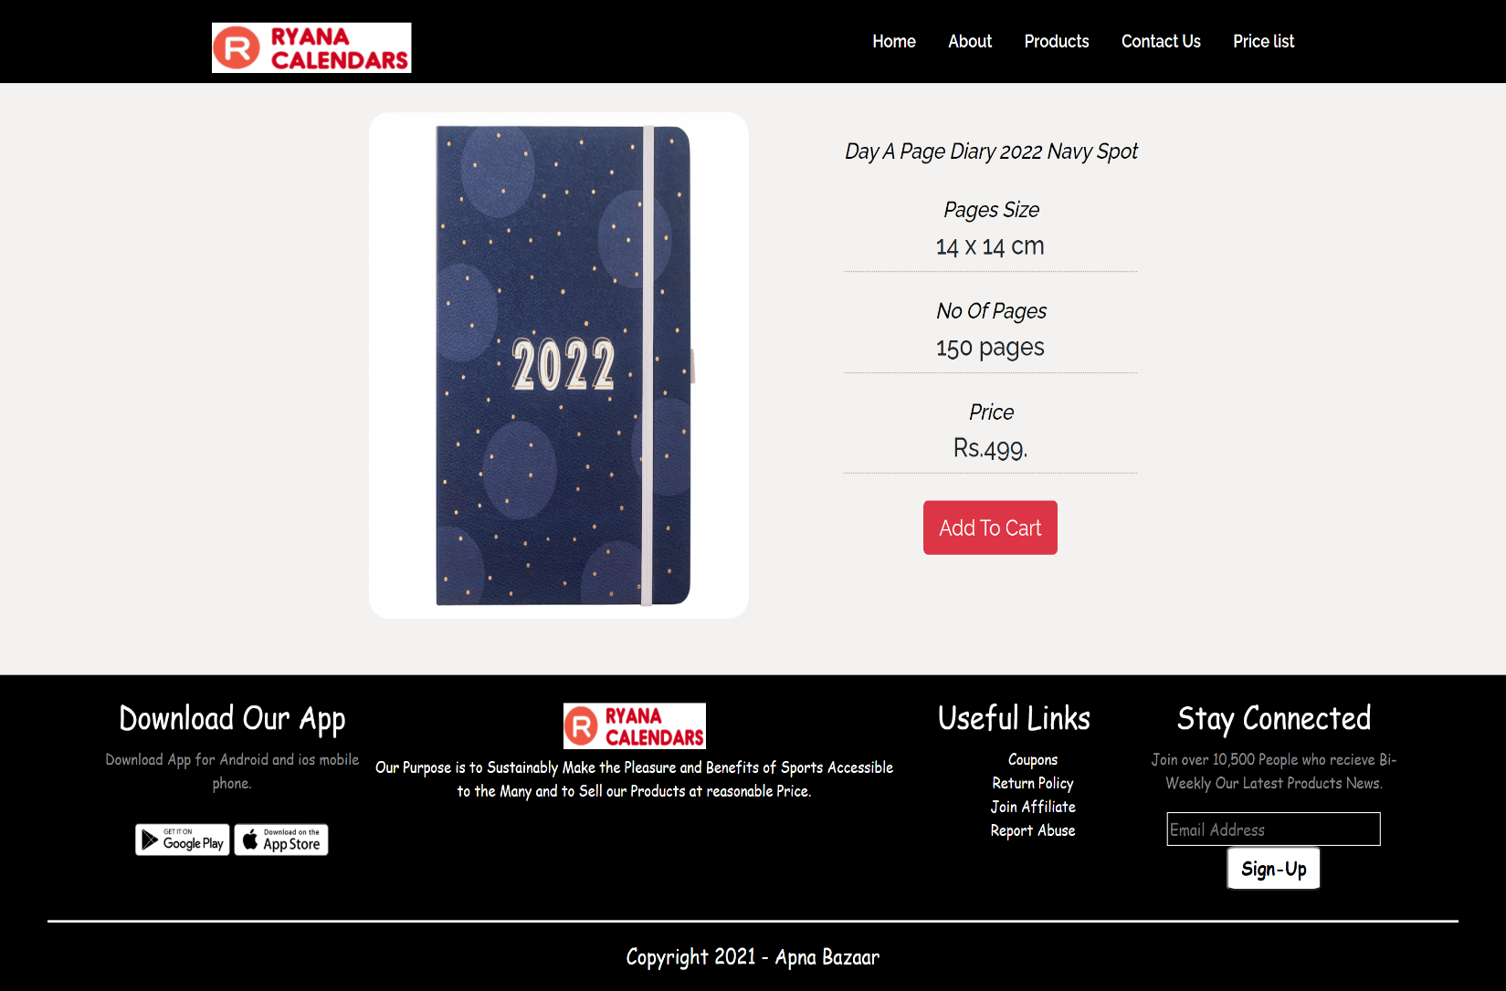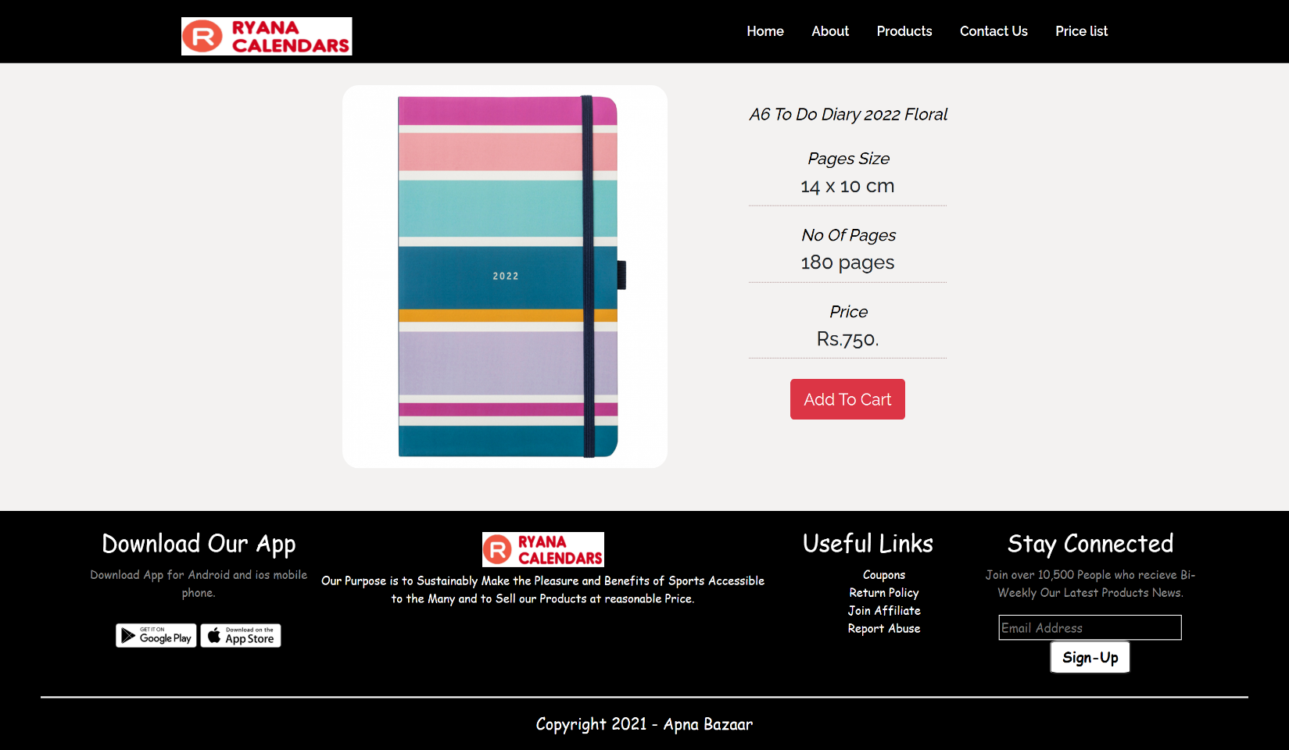

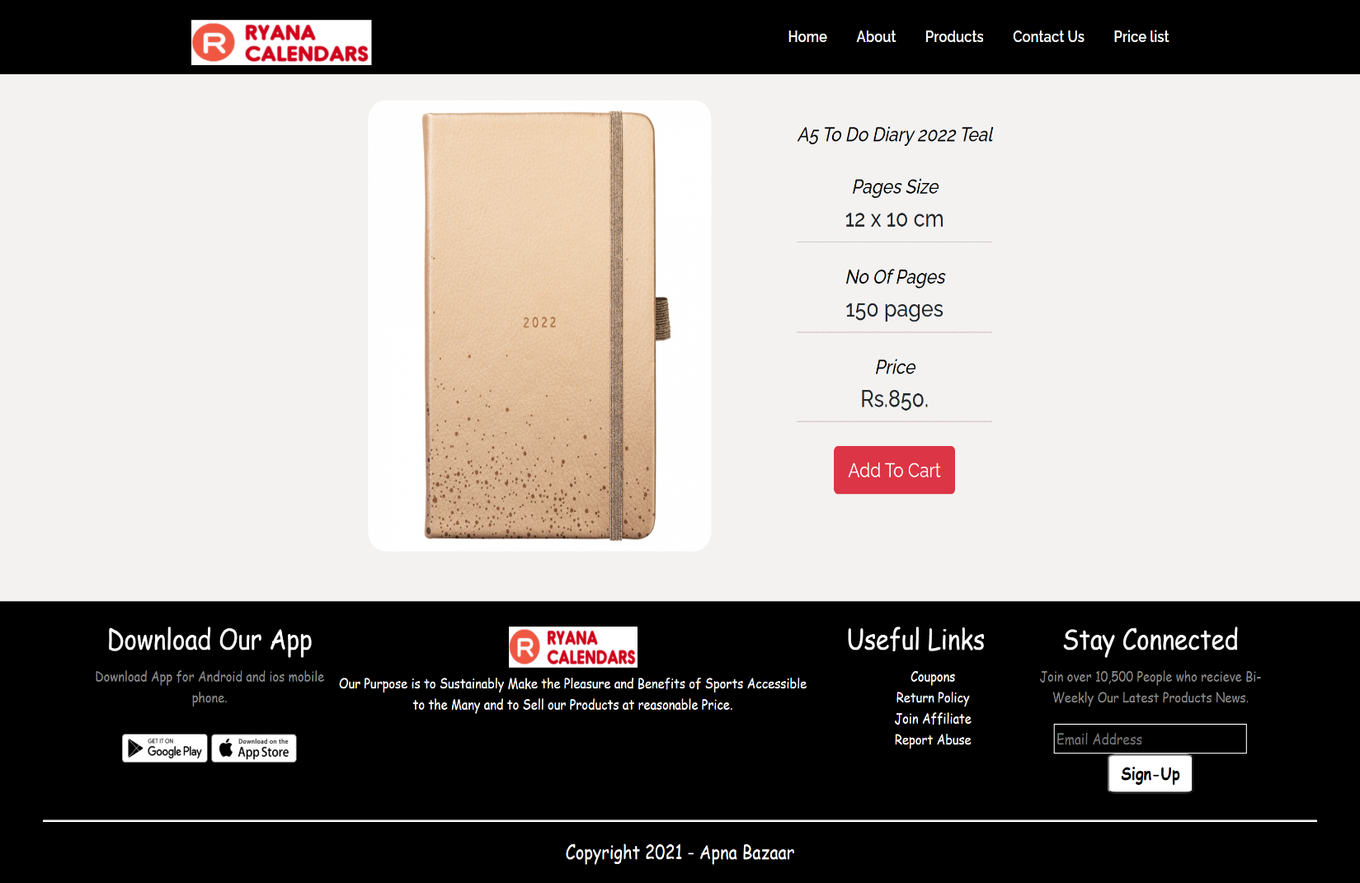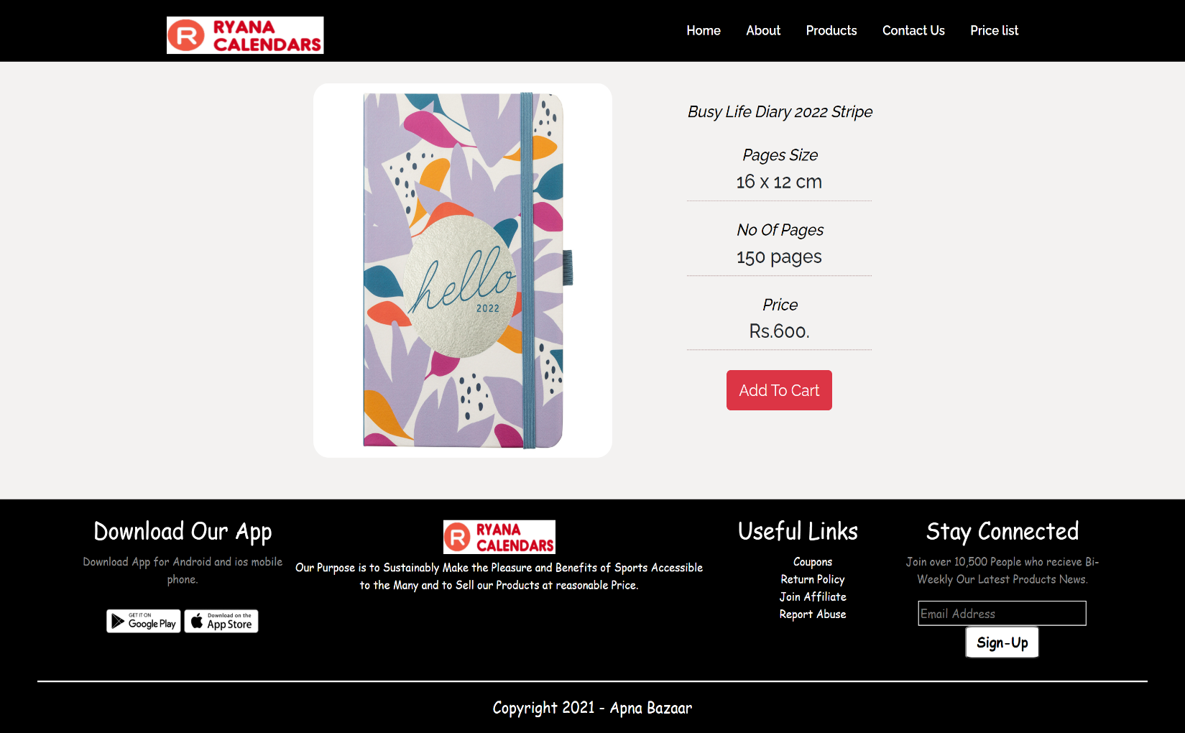

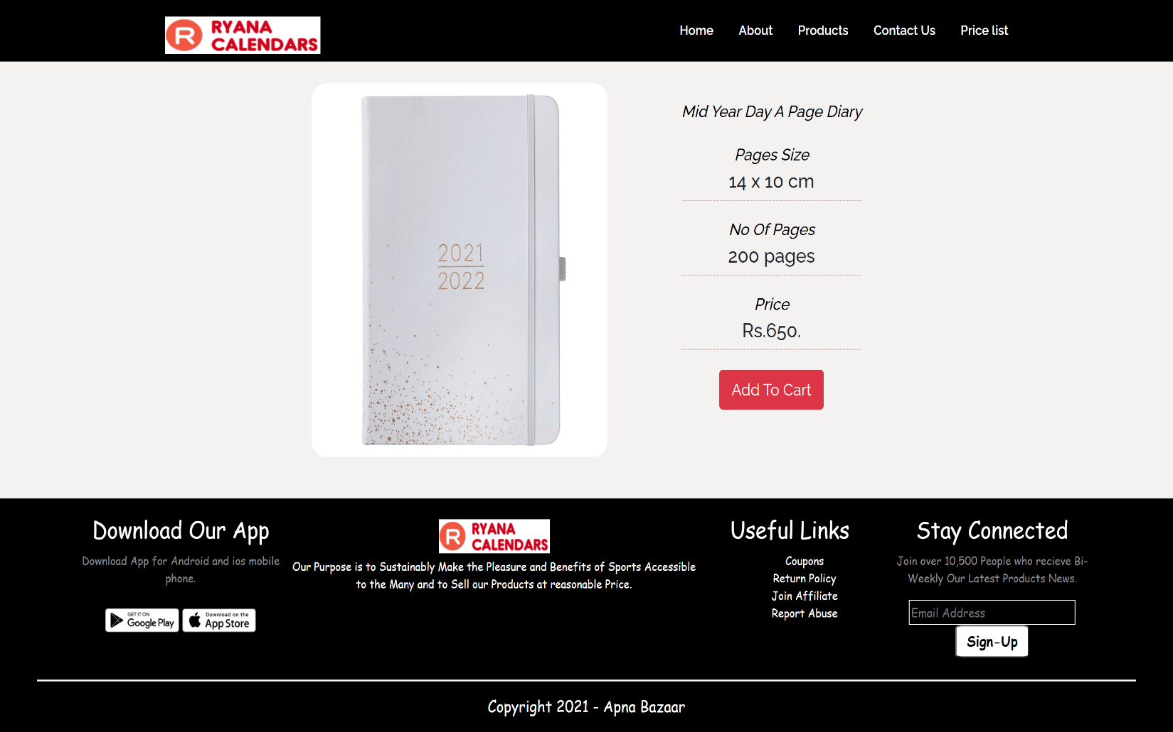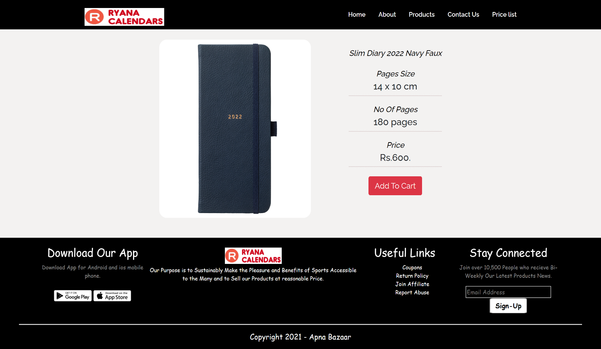

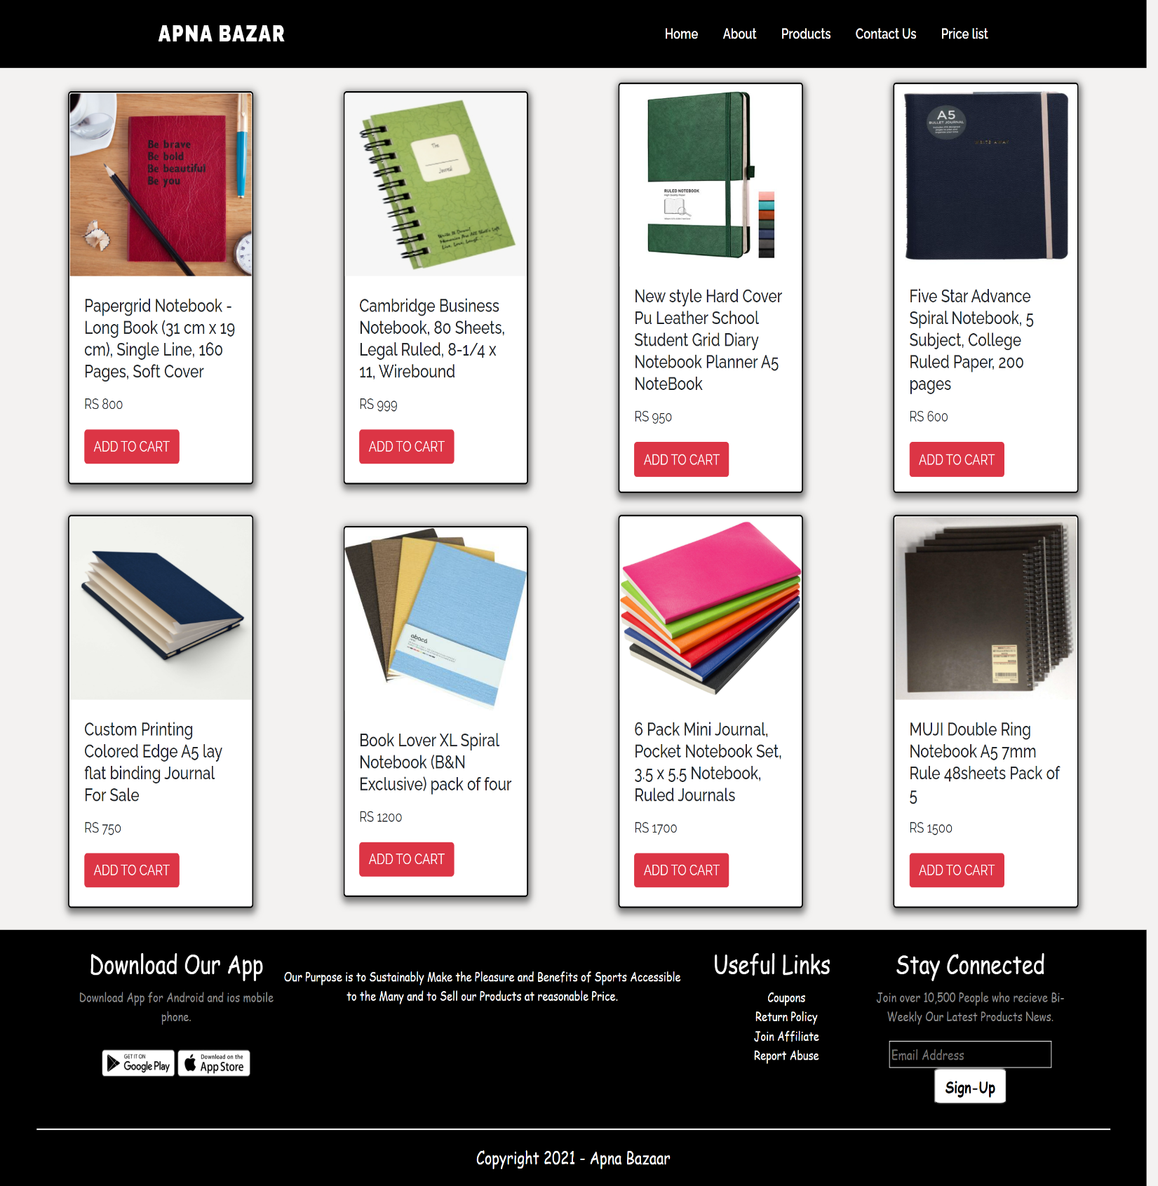***JOURNAL PAGE:***

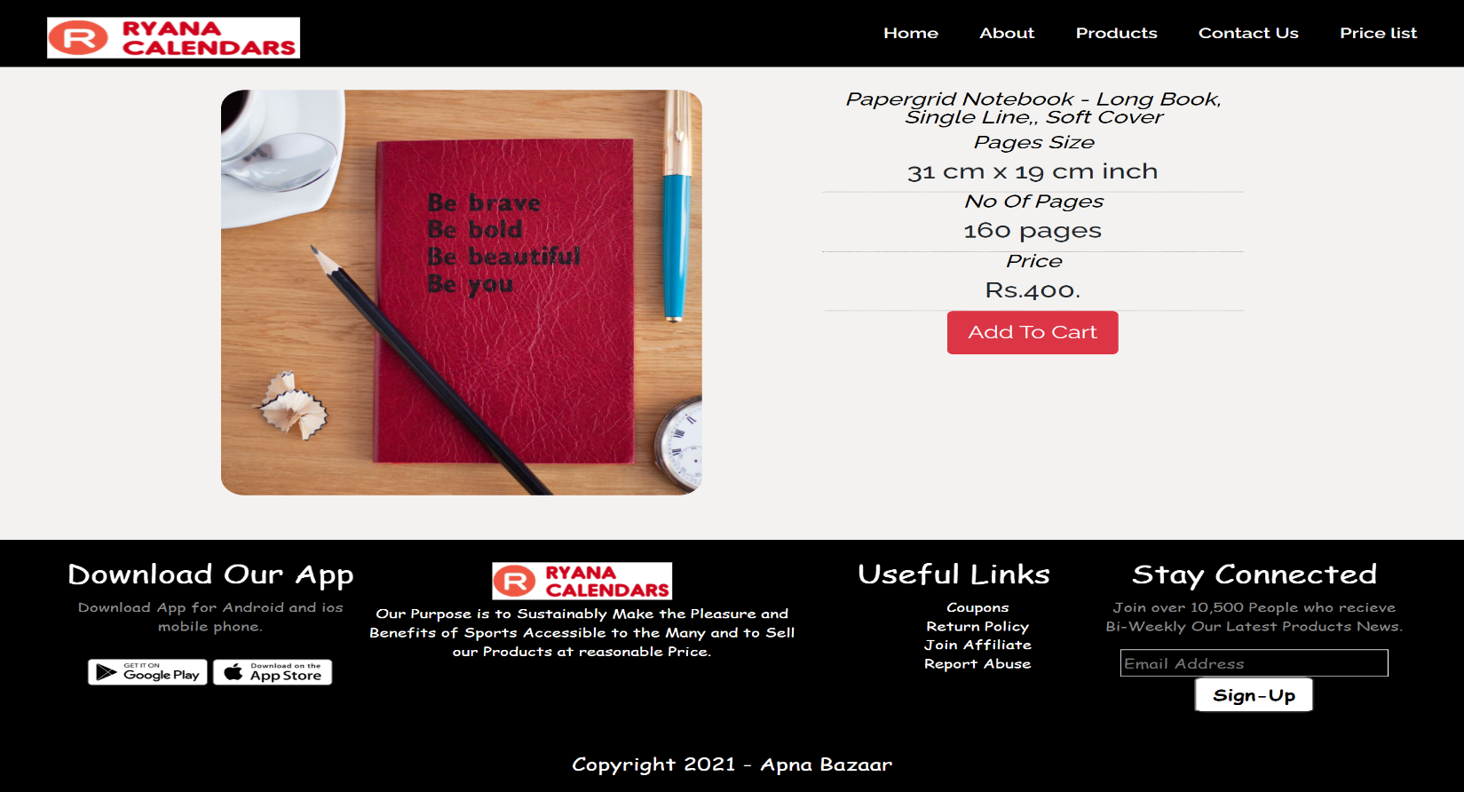***JOURNAL ITEMS INDIVIDUAL PAGES:***

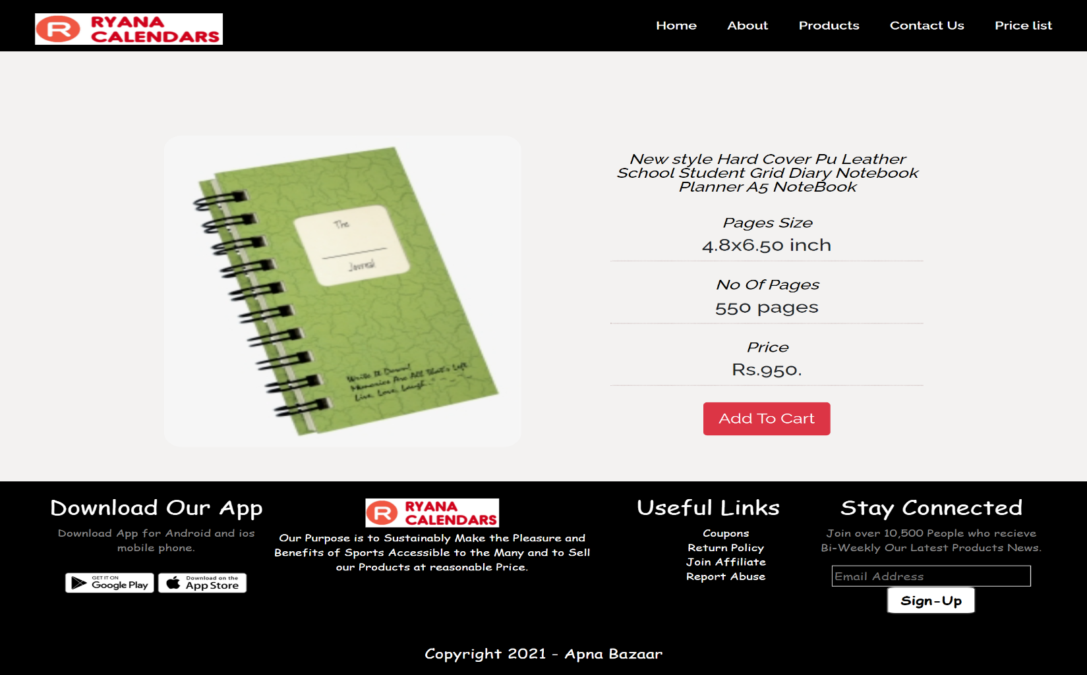

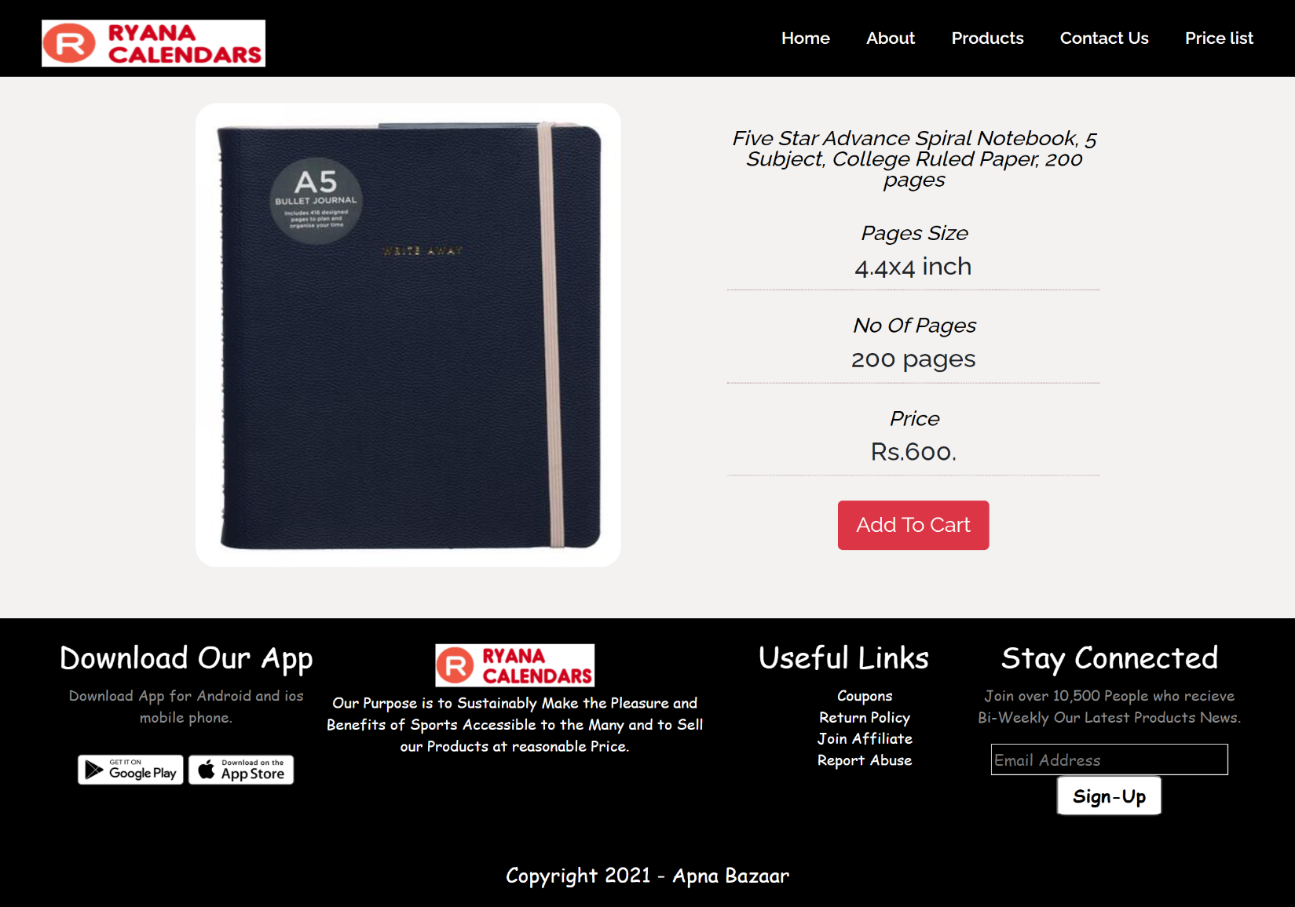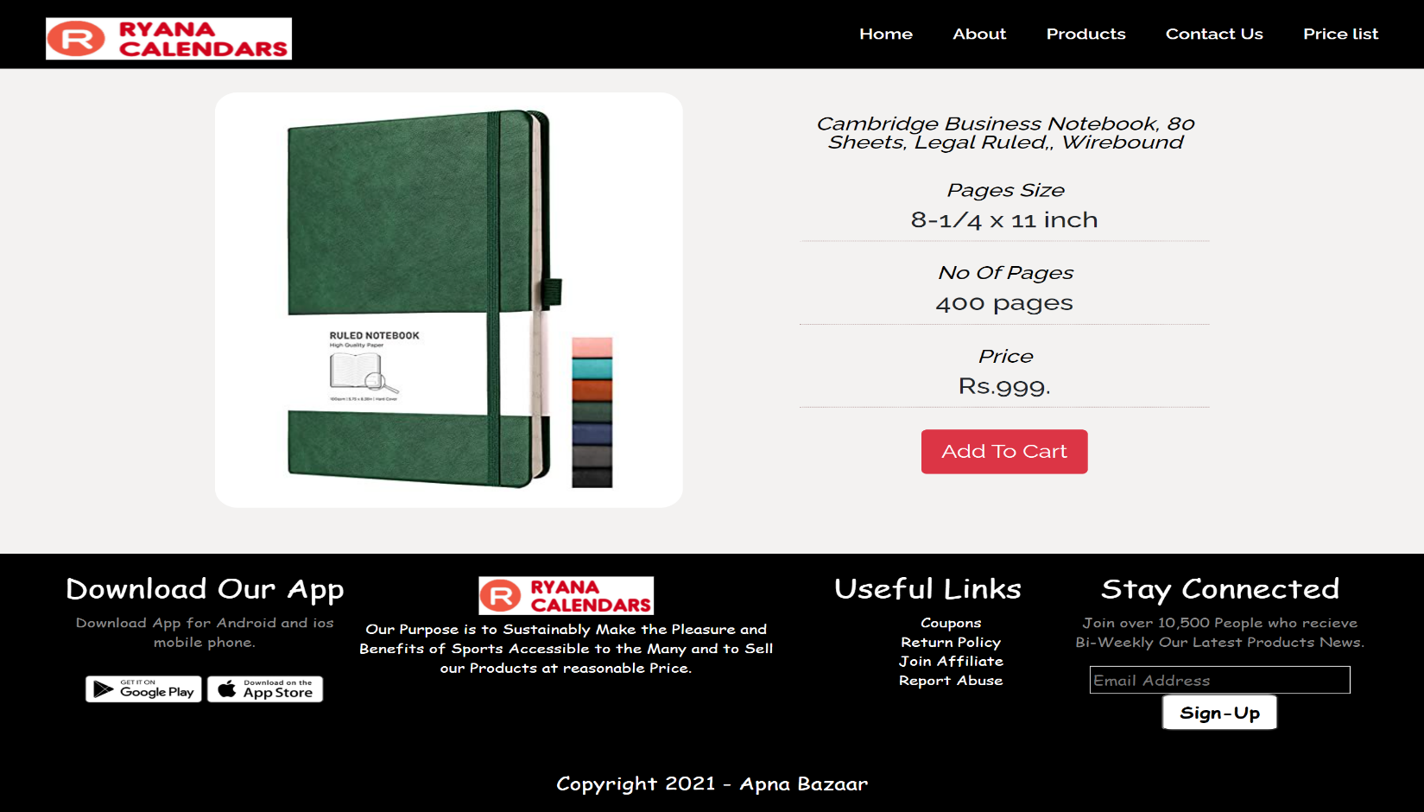

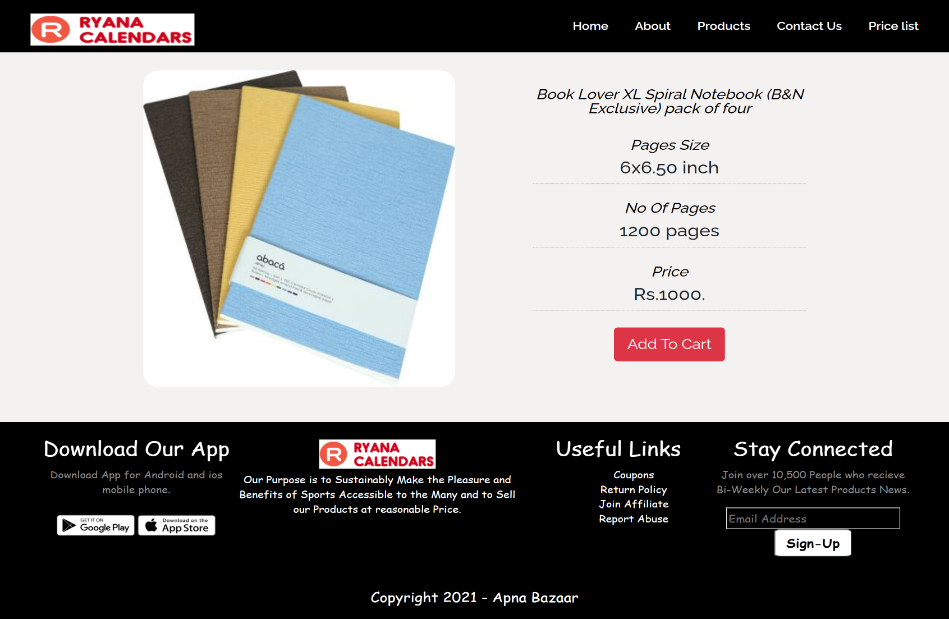

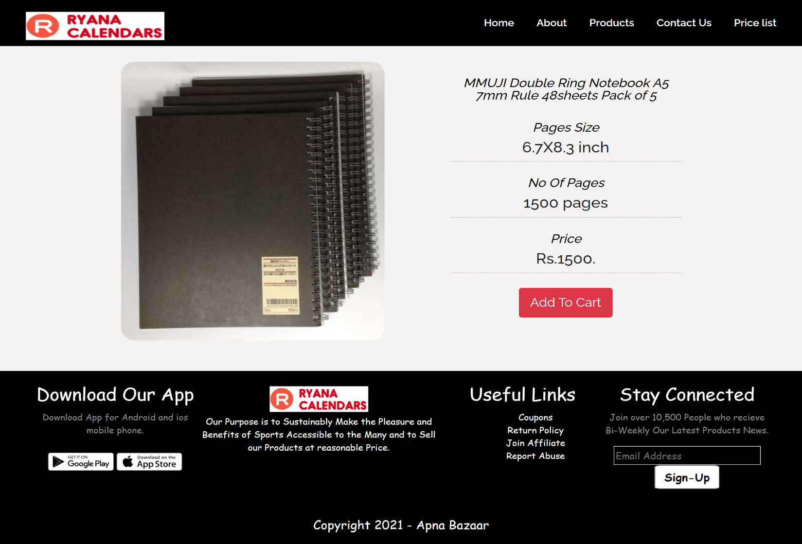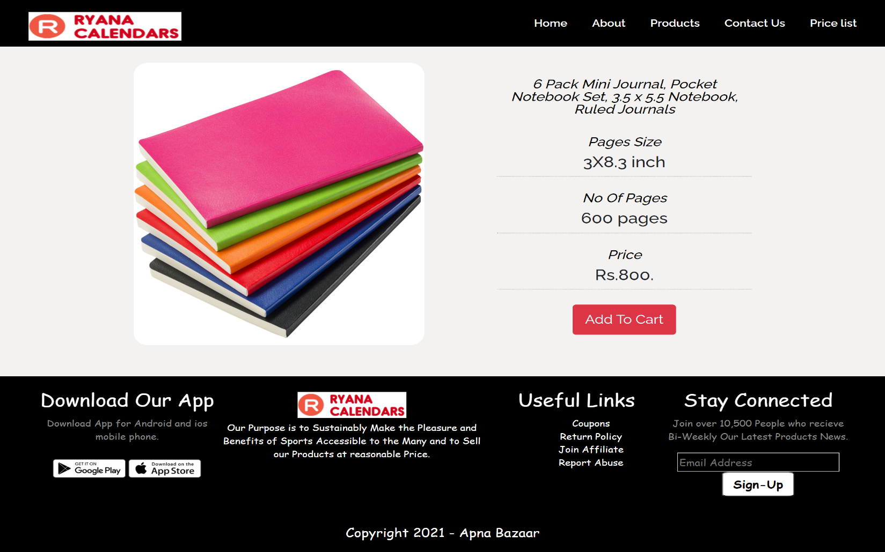

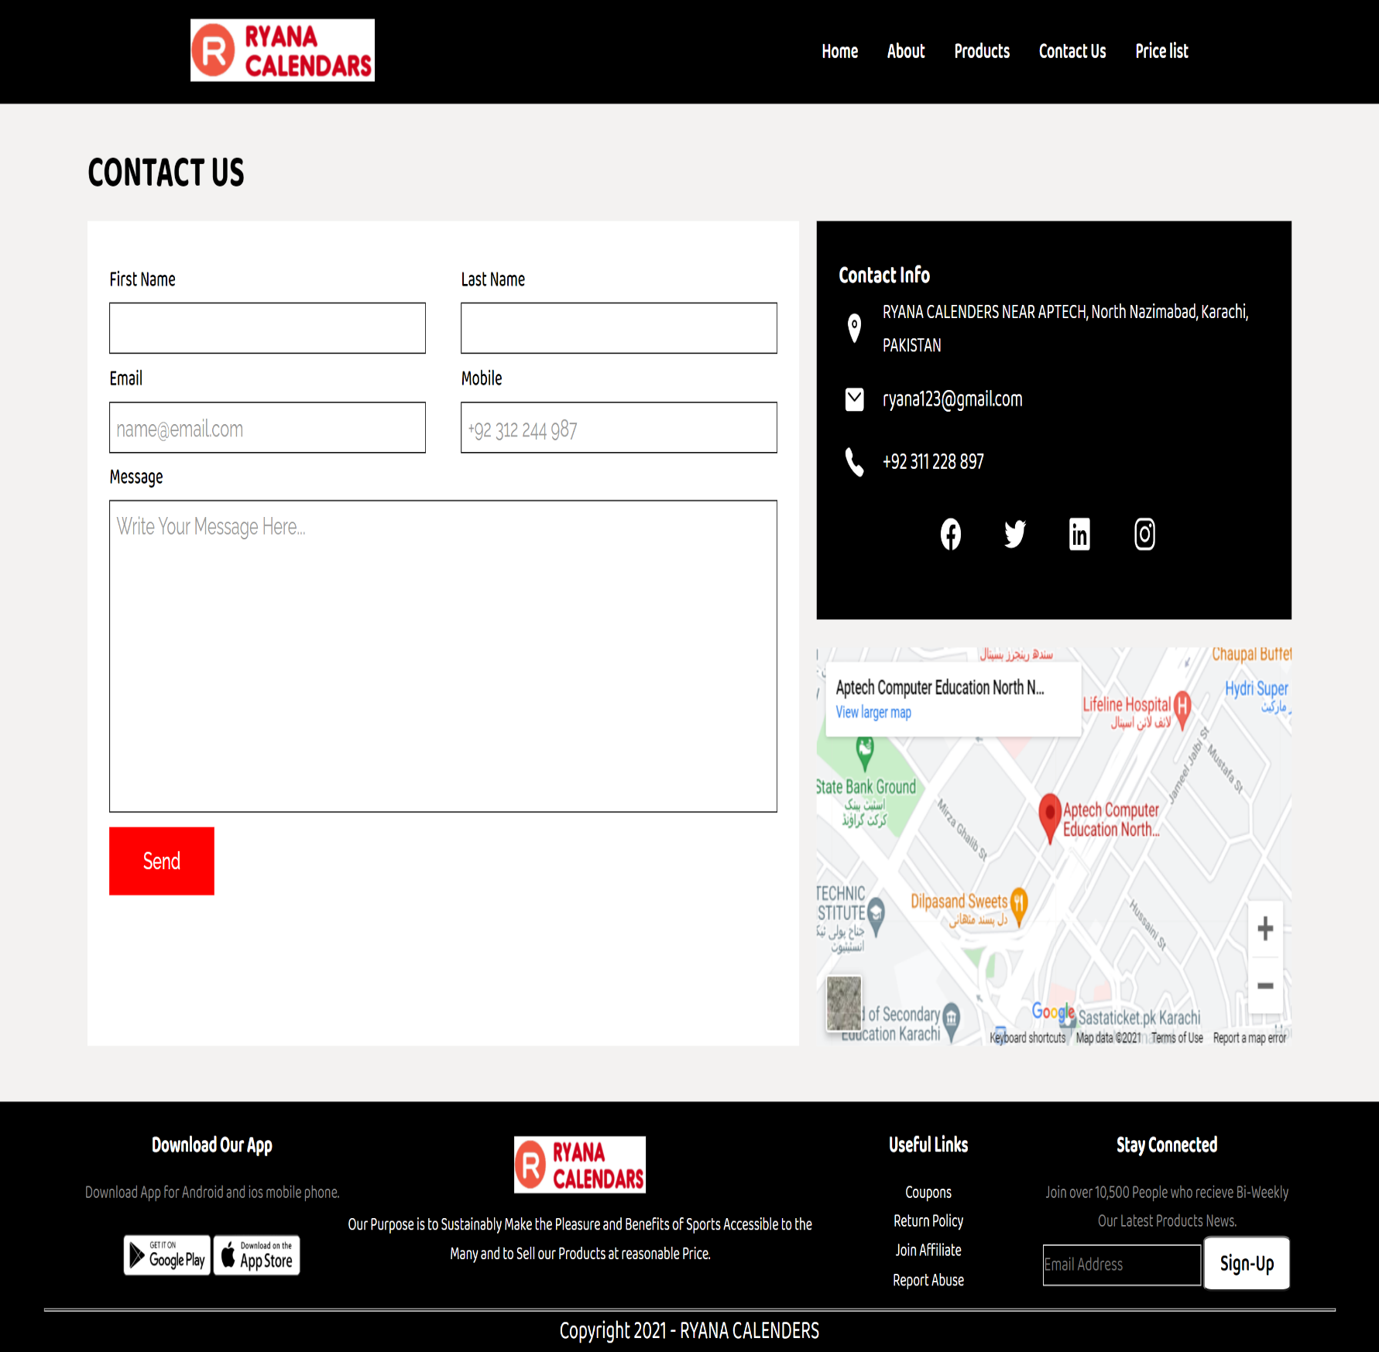***CONTACT US PAGE:***

***E-PROJECT DEATAILS (FOR USER AND DEVELOPER)***

***USER GUIDE***

Hello Users, Welcome to Ryana Calendars (online shop)

Here you can buy number of products like calendars, dairies, journals etc. Now I will give you the brief introduction about our website.

Basically our website is divide into 5 parts which are following:

These parts are present on navigation bar i.e. Home, about, Products, Contact and Price list.

First there is our home page where you can see our exclusive deals on the products, the we have an about Us page where you can know about us example number of products we have, number of clients, number of orders, number of shipping’s etc., you will also get to know about our background and our objective for making this website. Then on the home page if you click on the product present on the navigation bar you can see the different categories of our products like Calendars, dairies and Journals. Then you have to click on any category that you want to purchase or to see the products of that category you will got to the new page where you can see our products each product has individual detailed page by clicking on read more button, this page has all the details regarding the selected products and you can also buy them. Then we have a contact page where you will ask to put your First name, last name, email, Phone number and comments or any message that you want to share with us. On the same page you will find our address on google maps and our social media links, phone number and email address to contact with us any time. Then we have the last option which is Price list, so by clicking on this a word file will automatically downloaded on your computer, this file will contain all the product category, name, description and price so it will easy for you to go through all the available product.

***DEVELOPER’S GUIDE***

This guide will contain detailed description of modules present in our website to understand our code.

Following are the modules that are present in our website:

1. **INDEX.html PAGE:**

This page includes home page, about us, product category and a footer.

First we have make a prelaoder that will be execute before the execution of our website. Then we have a header section, this section contains our brand logo and navigation bar containing the links of different pages like home, about, products, contact Us and Price list.

By clicking on the price list a word file will automatically download on user’s computer, this file will contain all the product category, name, description and price so it will easy for you to go through all the available product.

Then we have an another section of home where we have background image and some content written on it and have a scroll down icon for scrolling down.

Then we have an about section where we have some content and 5 div regarding some of our information after that, we have an enroll button so that the user got enrolled.

Then we have a product category section these categories are the links of another pages which will be discussed afterwards.

At last we have a footer which contain some icons and content regarding to our website and for the interest of user.

1. **CALENDAR.html PAGE:**

As I discussed before about the product category that they are enclosed in an anchor tag so this is the first category page.

This page includes navigation bar, cards of products related to the category of calendar and footer.

For making different calendar cards, we have uses the bootstrap css and js for making our page responsive and quick. For this we have made two rows each row contains 4 cards and in total we have eight cards, each card includes image of the calendar, its description, its price and add to cart button.

1. **DIARY.html PAGE:**

This page is also the another category of products.

This page also includes navigation bar, cards of products related to the category of diary and footer.

For making different diary cards, we have uses the bootstrap css and js for making our page responsive and quick. For this we have made two rows each row contains 4 cards and in total we have eight cards, each card includes image of the Diary, its description, its price and add to cart button.

1. **JOURNAL.html PAGE:**

This page is also the another category of products.

This page also includes navigation bar, cards of products related to the category of journal and footer.

For making different journal cards, we have uses the bootstrap css and js for making our page responsive and quick. For this we have made two rows each row contains 4 cards and in total we have eight cards, each card includes image of the journal, its description, its price and add to cart button.

1. **CONTACT.html PAGE:**

This page contains navigation bar, contact us section and a footer.

The contact us section contains a form a having 5 inputs which are First name, last name, email, phone number and message/comment section where the user can write or convey message. On the right hand side of this form we have another div containing shop address, phone number, and social media icons for contact and at the bottom of this we have embedded the google maps containing our location.

1. **INDIVIDUAL PRODUCT PAGES:**

We have individual pages for each product fall in category of Calendar, Diary and Journal.(each category has 8 products and 8 detail pages)

**NOTE:**

As per the project we have include all thing that our project demand and the things that we knew as a frontend developer, we don’t have any data base or backend for this website.

***\*\*\*\*\*\*\*\*\*\*\*\*\*\*\*\*\*\*\*\*\*\*\*\*\*\*\*\*\*\*\*\*\*\*\*\*\*\*\*\*\*\*\*\*\*\*The end***

***\*\*\*\*\*\*\*\*\*\*\*\*\*\*\*\*\*\*\*\*\*\*\*\*\*\*\*\*\*\*\*\*\*\*\*\*\*\*\*\*\*\*\*\*\*\****